Data Engineering Projects
Three carefully designed projects can cover the core Data Engineering skills in your target role, provided we build them progressively and include the required production scenarios.

Our 3-project plan
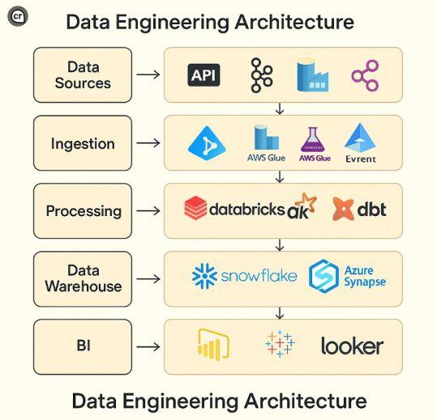

Project 1 — Batch Data Engineering Pipeline
Start here
Goal: Build a complete pipeline from source data to clean, usable outputs.
- Python, CSV, JSON, SQL Server and ADLS ingestion
- PySpark transformations, joins and aggregations
- Data types, NULLs, duplicates and business-rule validation
- Valid/rejected records and audit counts
- Bronze/Silver/Gold data layers
- ADF orchestration and basic monitoring
Outcome: confidently build a batch ETL/ELT pipeline.
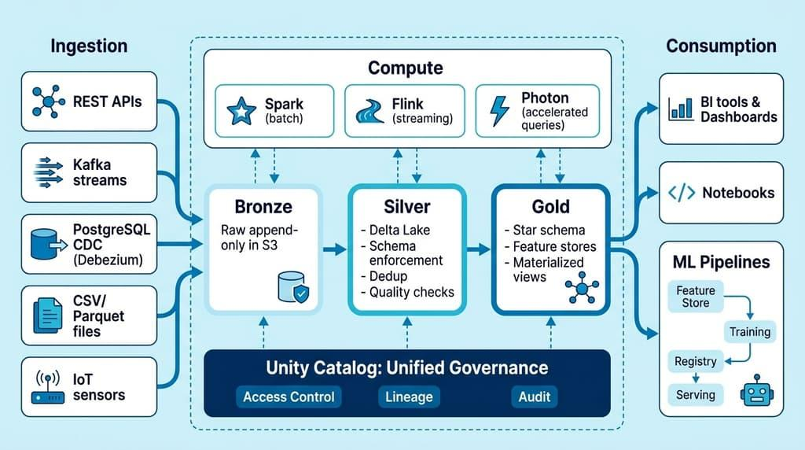

Project 2 — Incremental and Reliable Data Platform
Goal: Handle changing data safely and efficiently.
- Watermarks and incremental extraction
- CDC concepts, inserts, updates and deletes
- Delta Lake and MERGE
- Batch-wise files and metadata-driven processing
- Idempotency, retries, recovery and checkpoints
- Schema evolution, testing and operational logging
Outcome: build restartable pipelines that process changes without unintended duplicates.
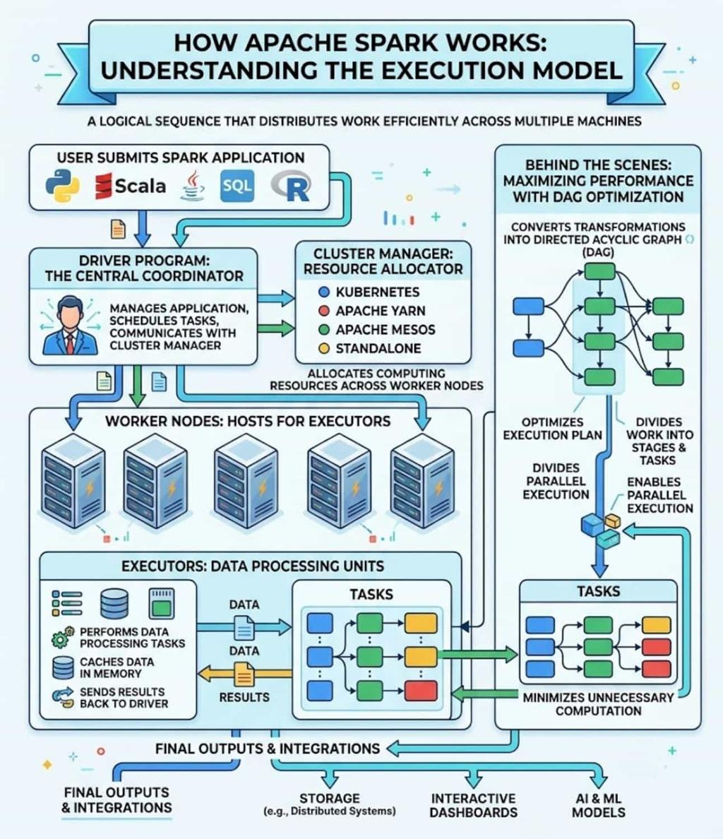

Project 3 — Scalable Production Data Platform
Goal: Design, tune and operate a larger data-processing solution.
- Spark execution plans, partitions, shuffles and skew
- Join optimization and appropriate caching
- Larger data volumes and file-size management
- ADF and Databricks job orchestration
- Monitoring, alerts, security and deployment
- Performance benchmarking and architecture decisions
- End-to-end troubleshooting and interview scenarios
Outcome: explain and defend production-oriented Data Engineering designs.

What about the other technologies?
Skill | Where we cover it
Python, Pandas, APIs, SQL Server | Projects 1 and 2
Azure Data Factory and ADLS | All three
Databricks and PySpark | All three
Delta Lake and medallion architecture | Projects 1 and 2
Incremental loading and CDC | Project 2
Spark optimization | Project 3
Logging, testing, recovery and monitoring | All three, progressively
Git, deployment and security | Projects 2 and 3
Power BI consumption and data modelling | Projects 1 and 3
We will also cover the relevant Synapse, Spark SQL, and Azure integration concepts where they fit the architecture. We won't force every Azure service into every project.

How long?
A reasonable initial target is 8–12 weeks at around 6 hours per day, with adjustments based on your existing knowledge and how independently you can complete each milestone.
Dear, one thing is important: we won't abandon Project 1 halfway through because we discover a new topic. We'll finish its agreed requirements, then extend the same foundation in Project 2 and Project 3.
Three projects. One integrated learning path. One clear completion goal: becoming capable of building and explaining end-to-end Data Engineering pipelines.

